About the project
This is an OpenAPI/Swagger definition based REST web service using SpringBoot.

1. Build the project through maven using:
mvn clean install

2. Run it using:
mvn exec:java

3. Open web browser and go to: http://localhost:7162/v1/swagger-ui.html
This will open the generated Swagger UI which can be used to test the Country API.

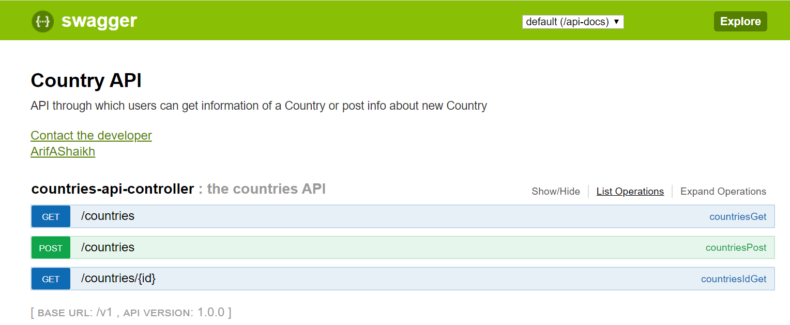

If you do not know about Swagger UI read this:

What is Swagger UI?
Swagger UI, a part of Swagger, is an open source tool that generates a web page that documents the APIs generated by the Swagger specification. This UI presentation of the APIs is user friendly and easy to understand, with all logic complexity kept behind the screen. This enables developers to execute and monitor the API requests they sent and the results they received, making it a great tool for developers, testers and end consumers to understand the end points they are testing. Swagger UI represents apis within browser so brings more intuitively than other tools such as: Postman, SoapUI, and others.

